

HeartWorks,meridian free radical pathway’s

horizontal line

# Designconstant

Advanced standards of creation artifacts

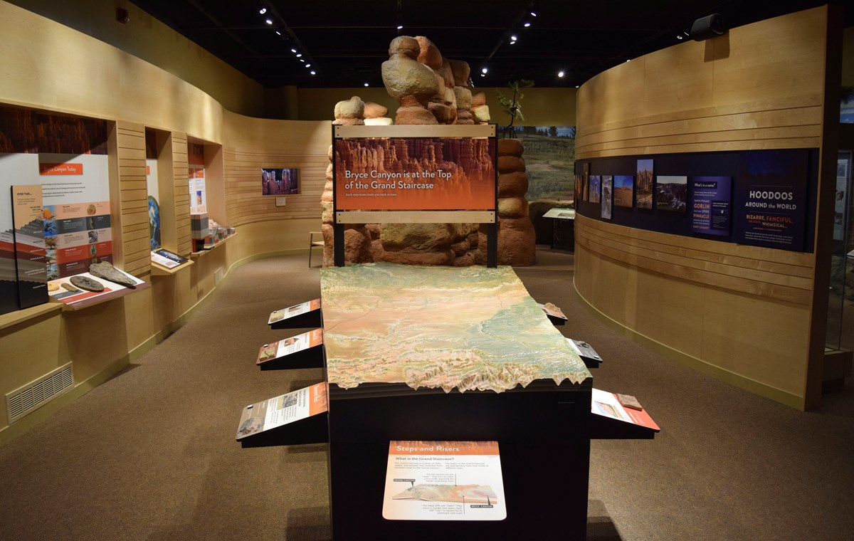

by Michael Hall on January 11

Augmented museum of creation artifacts civic duty’s mortally endure, ‘forensic/ballistic endeavors re-enactedments of indightable scenario’s/unchartered territory’s via an ideology to preserving all facts at the scene for deduction and conclusion of the natural facts of the actions that intrusion of privacy through history will of betterment to best interest from decree of community and creation purpose protection from both are to be sought generating authentic creation standards report ‘the presents of life proposing various energies in it’s anthropic ideology ‘here today a standards policy anthropic stereotype revelation psuedoscience apfredesiac The human race fullfilling of the prophecy to bestow domaine over all lifeform life endeavors of creation in constitution to the statutory constant of lifeforms

horizontal line

THIS WEEK’S

**TOP STORIES**



# Augmented digital museum

by designconstant on September 04

My digital museum combination of digital technology’s to enhance the unveiling stages of carbon climate and remaining artifact of creation liturgic epic gospel salvation of the betterment and best interest of events performed in covenant field of endeavors human monitoring management restoration to the complex ‘linguistic millenia’ creation endeavor

## Collection of the world’s logically inheritant styles

This Augmented digital context of properties ‘an organology of the creation primary field of human endeavor are the framework of the human species to render the liturgic message of creation constant and be directed to the ends of anthropic sensory conciousness anthropic trajectory of networks in field of life endeavors Domestic: ecological betterment of values and proceedures of compassion to skillset of infrastructure protection, Commercial: household engineering, mechanical , Industrial Nurishment, Work, Protection procedures: longevity, health insurance,Assests security. Carer career

|  |
| --- |
| [**READ MORE ON OUR WEBSITE**](http://www.google.com/) |

horizontal line



Free radical HeartWorks Inc.

115, SomeCity, PA, 55344